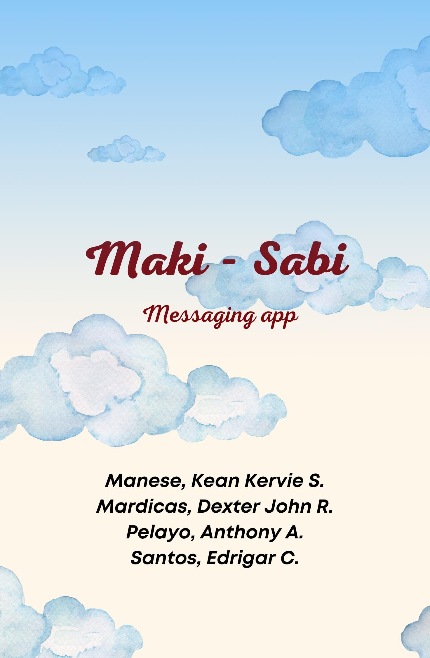

# Objective

- The Objective of this software is to introduce a live chatting

experience with your friends, family, or acquittances with this safe and reassuring chatting software named Maki-Sabi, with its own server start-up which allows a user to chat real time with the established server for privacy.

# Features

## Chill and Comfortable Background

* + - With the software’s eye-pleasing and not-so-vibrant colors, the software is much easier for the eyes and avoids strains on the user’s eyes.

## Easy Access

* + - The Users can easily access the software via the program to converse with one another.

## Simple Design

* + - Designs were kept simple to avoid confusion as to what specific functions may be used for, or where it may be.

## Compact

* + - Every function needed by the user will be found in a single tab.

# Functionality

## Chat box / Send Chat

* + - With this function, the user can exchange messages from user1 to user2 using the chat box function in which the user can formulate a message that will be sent to the user through the server established.

## Send Images

* + - Using the clip icon, users can send images exported from their local devices.

## Voice Message

* + - The user can record a live recording using the microphone symbol displayed beside the chat box.

## Enter Name

* + - This function allows the user to display the name of the person it is having a conversation with.

## Online Users

* + - This feature displays the users online within the server that it is using.

## Preview

* + - Before sending an image or file the user will be able to view the attachment before sending.

**II. Code Structures**

**HTML Structure**

**Header:** Contains meta tags and links to external resources like CSS and JavaScript libraries.

**Body:** Contains the main content of the application.

**Logo:** Displayed at the top using an <img> tag inside an <h1> element.

**Main Section:** Contains:

**User Name Input**: Allows users to enter their name.

**Message Container**: Lists all chat messages.

**Message Form**: Allows users to input messages and send files.

**Online Users Display**: Shows the number of online user.

**Background Video**: Plays in the background.